Activity #9: Airport Flight Screen with Live Tracking
Activity goal
In this activity, you will complete the JavaScript logic for an Airport Flight Screen. The HTML interface is already prepared for you. Your job is to make the page fully functional by writing the missing JavaScript logic.
- You must use the same API key that you already used in your Summative Project.
- Very Important: Do not redesign the page.
What the final page should do
Your finished page should allow the user to:
- choose an airport from the dropdown
- load flight data from the API
- show the current date and time updating live
- display flight details inside the table
- show a live tracking link when appropriate
- handle empty selections and possible missing data safely

What is Flightradar24?
Flightradar24 is a live flight tracking platform that shows aircraft movements in real time on a map. It provides information such as flight number, airline, route, altitude, speed, and current location. According to Flightradar24, it is a global flight tracking service that provides real-time information about aircraft around the world, using data sources such as ADS-B, MLAT, satellite, and radar data.
Purpose of Flightradar24 in this project
In this project, Flightradar24 is not the main data source. Your main flight data comes from the aviationstack API. Flightradar24 is used as an external live tracking viewer so the user can open a flight and see its movement visually on a real-time map when the aircraft is actually in the air.

How to integrate it with your project
You will use the flight number from the API response to build a link to Flightradar24. That link should appear only when the flight is active in the air. If the plane is on the ground or live tracking data is unavailable, display something like N/A instead. This makes your table smarter and more realistic.

Student instructions
Part 1: Understand the interface
Study the HTML file carefully. Notice that it already contains:
- a dropdown for airport selection
- two buttons
- a live date/time label
- a table body where rows will be inserted dynamically
- JavaScript function names already prepared for you
Before writing anything, identify what each function is supposed to do.

Part 2: Complete the time section
There are functions prepared for updating the current time.
Your task
Make the date and time update automatically every second.
Hints
- Use setInterval(...)
- Create a new Date object each time the clock updates
- Show the date/time inside the label with id current_date_time
- Make sure the timer starts when the page loads
Think carefully
- Do you want to show the raw date object, or a cleaner formatted version?
- Which format looks better for users?

Part 3: Load flights from the API
The page has a function for loading flights when the user clicks the button.
Your task
Fetch flight data using the airport code selected by the user.
Hints
- Read the selected airport from the dropdown
- Use the same API key from your summative project
- Build the request URL correctly
- Use fetch() and await response.json()
- Extract the array of flights from the returned result
Validation hint
Before sending the request:
- check if the user selected an airport
- if not, show an alert and stop the function
Think carefully
- Are you filtering by departure airport or arrival airport?
- Does the button label match the API filter you are using?
- Is the alert message accurate for the selected field?

Part 4: Display the flight rows in the table
After receiving the data, you need to generate table rows dynamically.
Your task
Loop through the flights array and build the table body HTML.
Hints
For each flight, try to display:
- flight date
- flight status
- flight IATA code
- airline name
- departure airport
- arrival airport
- arrival terminal
- scheduled time
- actual time
- live tracking link or N/A
Important hint
Some API fields may be:
- null
- missing
- nested inside objects
So do not assume every value always exists.
Think carefully
- What happens if live.is_ground is null?
- What should the user see instead of blank or broken values?

Part 5: Complete the “Load Active Flights” feature
There is another function prepared for active flights.
Your task
Load flight data and decide whether a Flightradar24 link should be shown.
Hints
- Look at the live object returned by the API
- Check whether the aircraft is on the ground or in the air
- Only show the tracking link if the plane is actually flying
- If not, display N/A
Logic hint
Ask yourself:
- Is the live object always available?
- If live is null, can you still assume the plane is flying?
- Which property tells you whether the aircraft is on the ground?

Part 6: Build the Flightradar24 tracking link
The table has a final column for live tracking.
Your task
Create a clickable link that opens Flightradar24 in a new tab.
Hints
- Use the flight IATA code in the URL
- Open the link with target="_blank"
- Show the link text as something simple like View
- Only show the link when your logic confirms the flight is in the air
Think carefully
- Is the flight number always safe to use directly?
- What should happen if the flight code is missing?

Part 7: Improve reliability
A good project should not break when the API returns incomplete data.
Your task
Add safe fallbacks.
Hints
Whenever data may be missing, display:
- N/A
- Unknown
- Not Available
Examples of fields that may need fallback values
- terminal
- actual time
- live data

Part 8: Challenge improvements
After making the page work, improve the experience.
Suggested improvements
- format the date/time nicely
- format scheduled and actual times for easier reading
- show a message when no flights are returned
- disable buttons until an airport is selected
- add row colors based on flight status
- initialize DataTables correctly if you want sorting/searching

What students should notice from the starter file
The starter file already gives strong clues about:
- function names
- which DOM elements to target
- how the API response is structured
- which fields should go into the table
- where Flightradar24 should appear
That means your task is mainly to complete the logic, not redesign the page.
Example for a Completed Work:
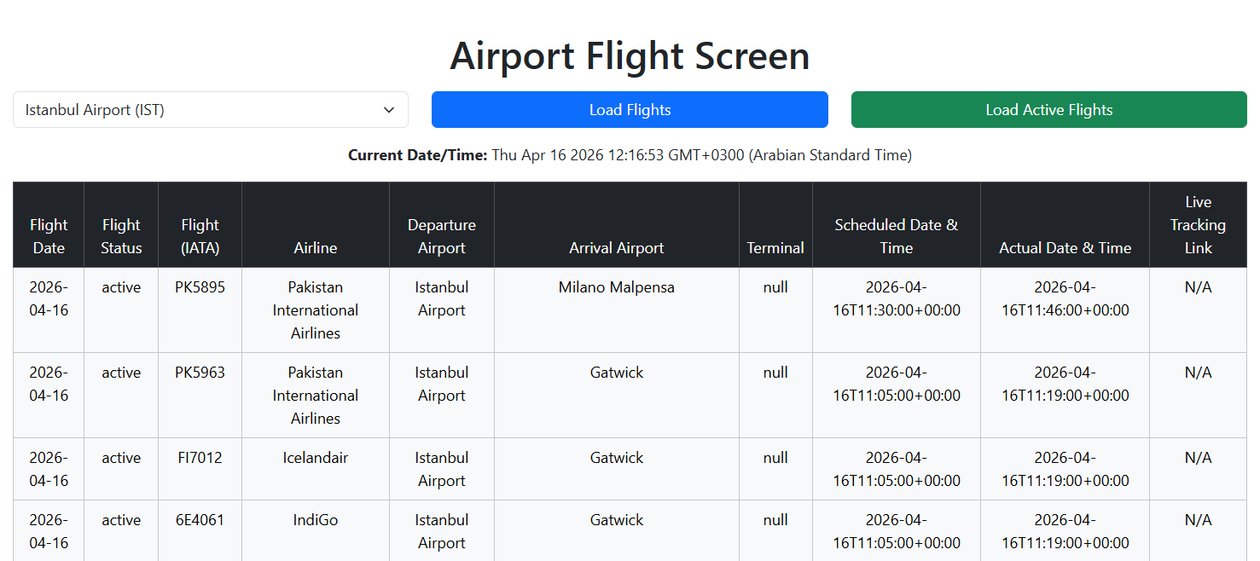
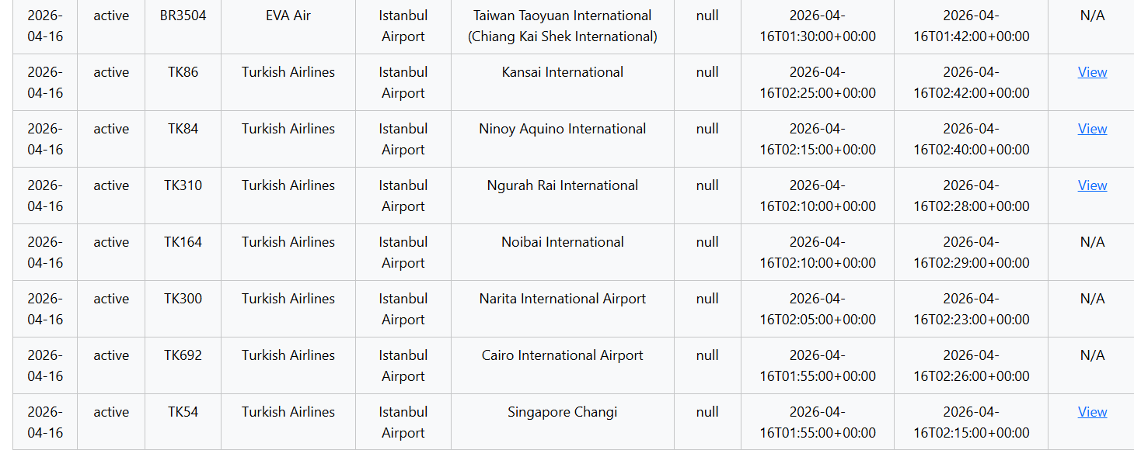
Activity #9 – Rubric:
Criteria | Excellent (Full Marks) | Good | Basic | Limited / Missing | Marks
1. API Integration (6 marks) | Correct API usage, proper endpoint, correct parameters, and working fetch logic with student’s own API key | Minor issues but data loads correctly | API works partially (errors or incorrect filtering) | API not working or missing | /6
2. Data Display in Table (6 marks) | All required flight data correctly displayed and structured in table rows | Most data displayed correctly with minor issues | Some fields missing or incorrectly mapped | Table not populated or incorrect structure | /6
3. Time & Date Functionality (4 marks) | Live time updates every second and is clearly formatted | Time updates but formatting is unclear | Time shown but not updating dynamically | Time feature missing or incorrect | /4
4. User Input Validation (4 marks) | Proper validation with clear alerts and prevention of invalid actions | Validation present but not fully handled | Basic validation but inconsistent | No validation implemented | /4
5. Active Flights & Logic Handling (4 marks) | Correctly determines flight status and handles live vs ground logic accurately | Logic mostly correct with minor mistakes | Logic partially correct but inconsistent | No logic or incorrect handling | /4
6. Flightradar24 Integration (3 marks) | Correct link generation and shown only when appropriate (in-air flights) | Link works but shown incorrectly sometimes | Link partially working or inconsistent | No link or incorrect implementation | /4
7. Code Quality & Error Handling (3 marks) | Clean, readable code with proper handling of null/missing data | Mostly clean with minor issues | Some effort to handle errors but incomplete | Poor code structure and no error handling | /2
Total: /30

